**REPORT: SERVO LIFECYCLE SETUP**

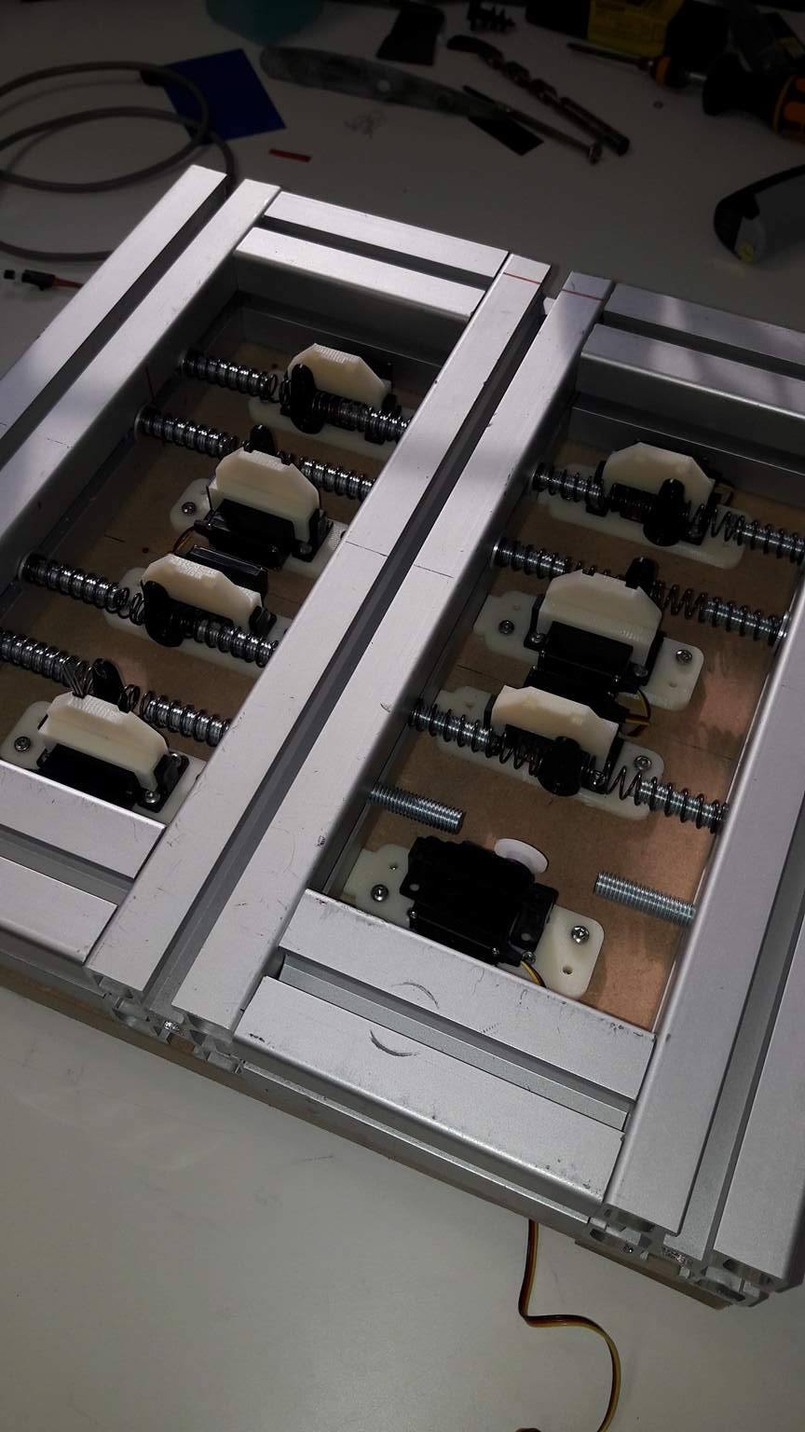

**Electronics:**

1. Hall switch (digital input):

* 3-pin
* measure directly after position command
* high signal without magnetic field (servo still moving), low signal with magnetic field (servo broken, stuck in neutral position by springs)
* pull-up resistor (4700Ohm) needed between signal and supply line
* fixed in printed servo holder (eventually some extra glue)
* magnetic disk pasted to servo horn (largest radius possible, aligned with sensor), remark north and south pole
* fed by Arduino
* additional small PCB needed for resistors

<http://www.hobbytronics.co.uk/arduino-tutorial11-hall-effect>

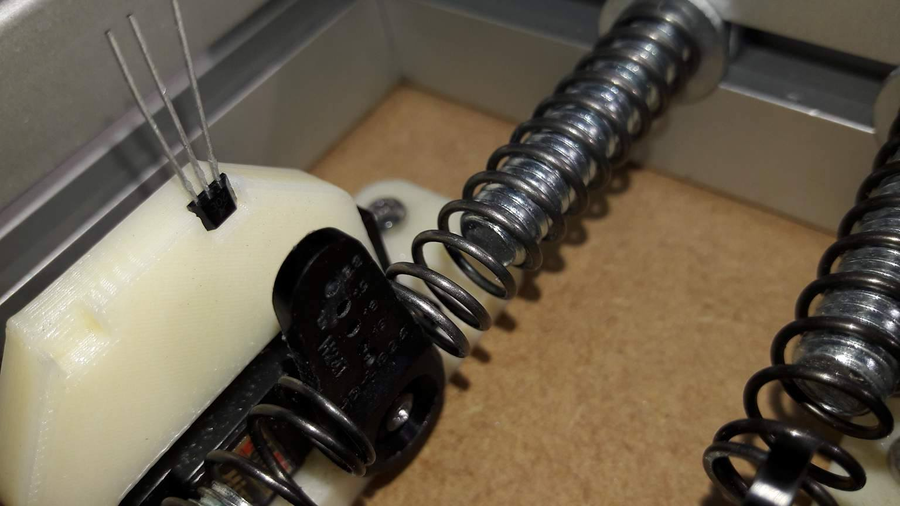

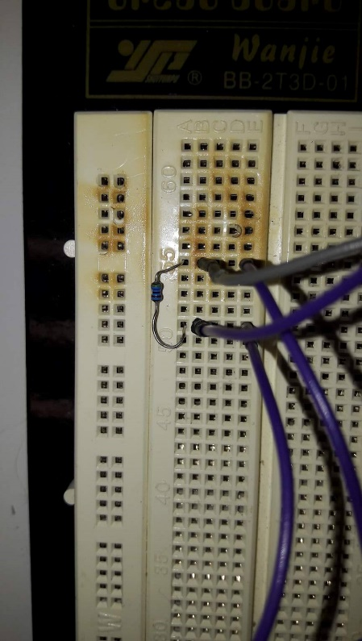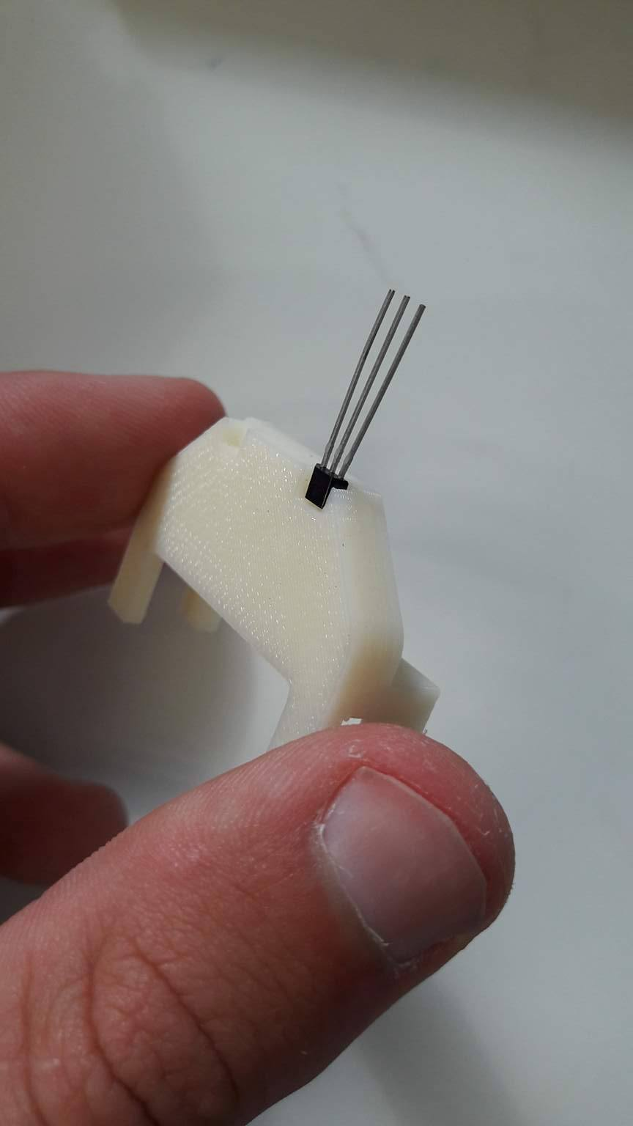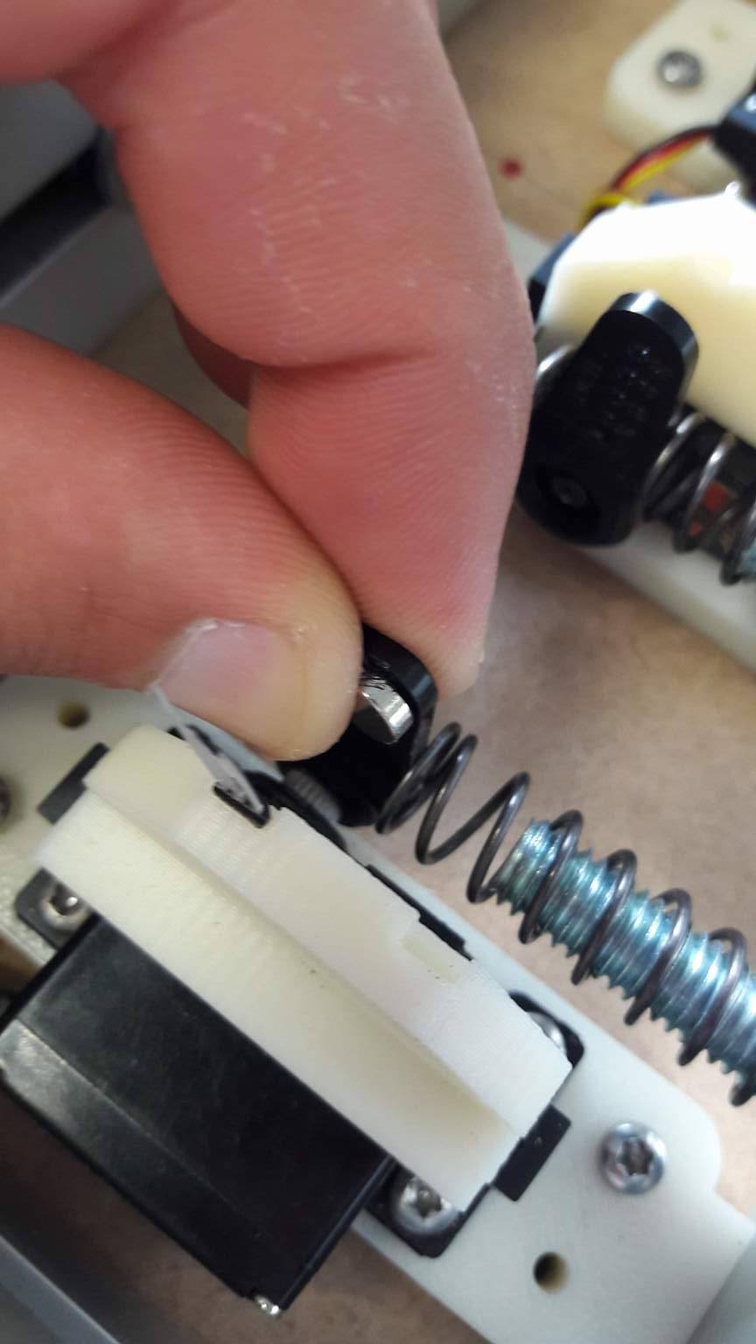

*Pull-up resistor – Hall switch in printed servo holder – magnetic disk on servo horn*

1. Temperature sensor (analog input):

* 3-pin
* internal calibration provided
* voltage proportional to temperature (with offset)
* sensor taped to servo case (at hotspot)
* fed by Arduino

<https://learn.sparkfun.com/tutorials/sik-experiment-guide-for-arduino---v32/experiment-7-reading-a-temperature-sensor>

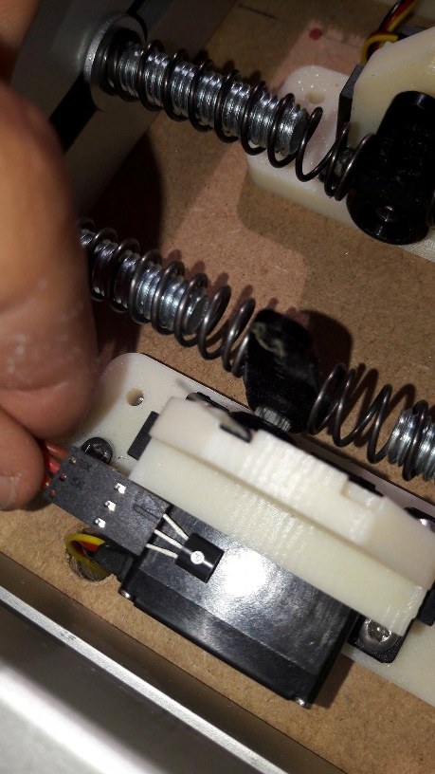

*Temperature sensor on servo case*

1. Shunt (current) resistor (analog input):

* voltage drop (maximum 0.2V) over small resistor (0.1Ohm with low tolerance) to obtain current, measure voltage after resistor
* additional small PCB needed for resistors

1. Arduino:

* fed by PC over USB (also serial communication)
* Mega version for additional pins (also considering serial servo protocol, see SBUS scheme)
* soldering to PCBs still needs to be done

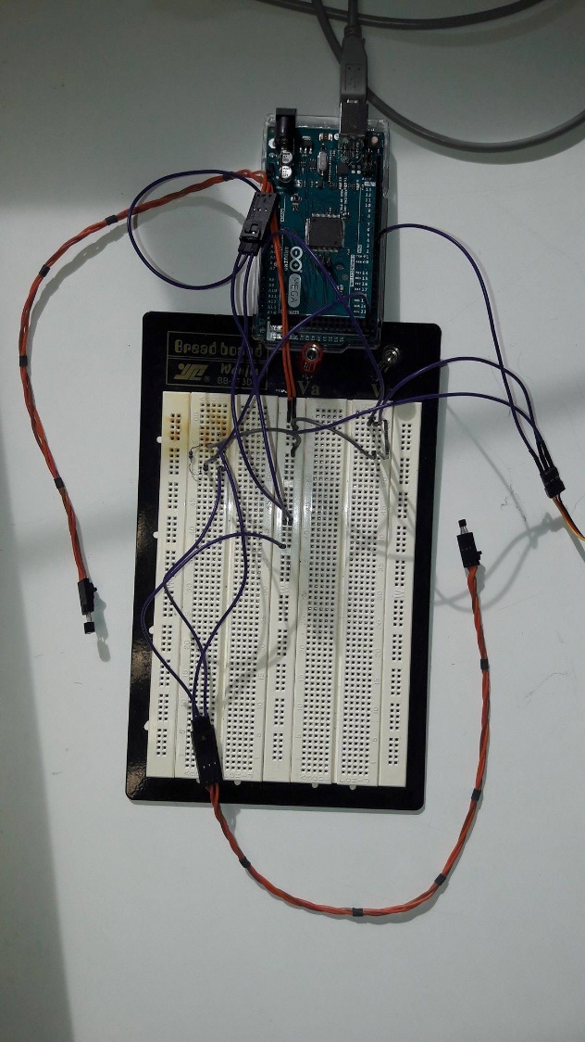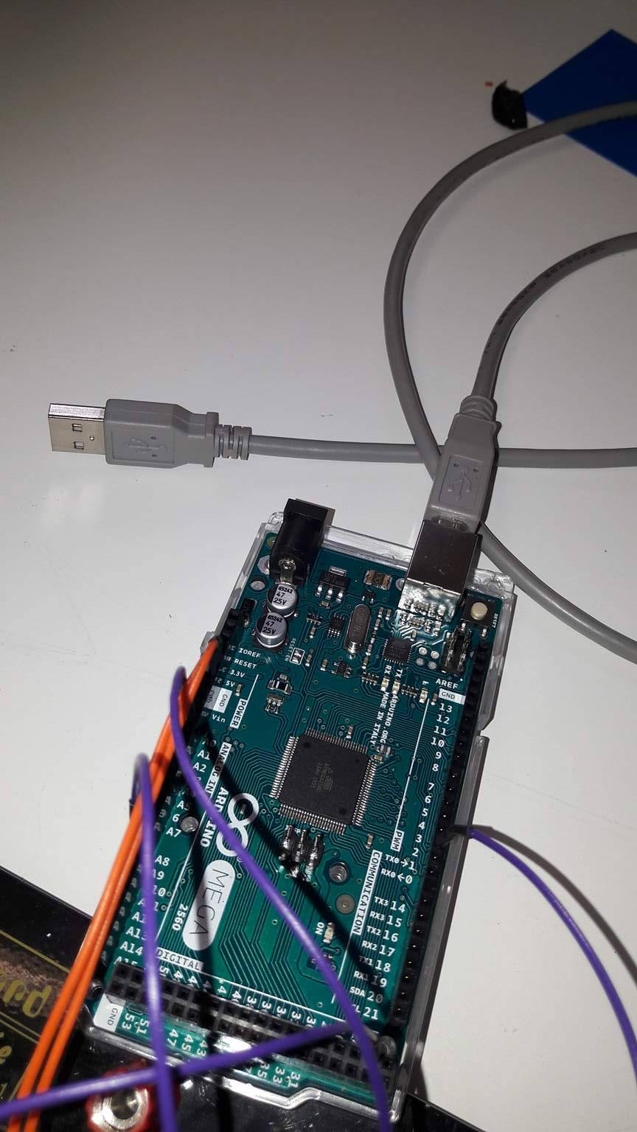

*Wires for 1 servo (and thus 2, in fact 3, sensors) on PCB – on Arduino*

1. Bench power supply:

* AC power cable for L-N-PE (still needs to be stripped), DC power cable for –V-+V

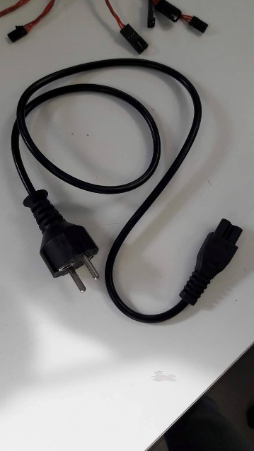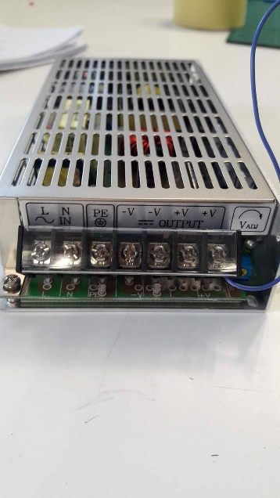

*AC power cable – bench power supply pins*

**Mechanics:**

1. Pressure springs:

* 2 per servo (both sides of servo horn for left and right pull-out counterforce)
* length fixed (eventually pretension), diameter variable, stiffness variable dependent on load test (also determined by angle, see SolidWorks sketch and Excel sheet)
* washers between Minitec and springs, still component needed between springs and servo horn
* threaded pens (in fixing nuts) to avoid buckling (eventually grind thread to decrease friction), still can be cut to attain higher angles

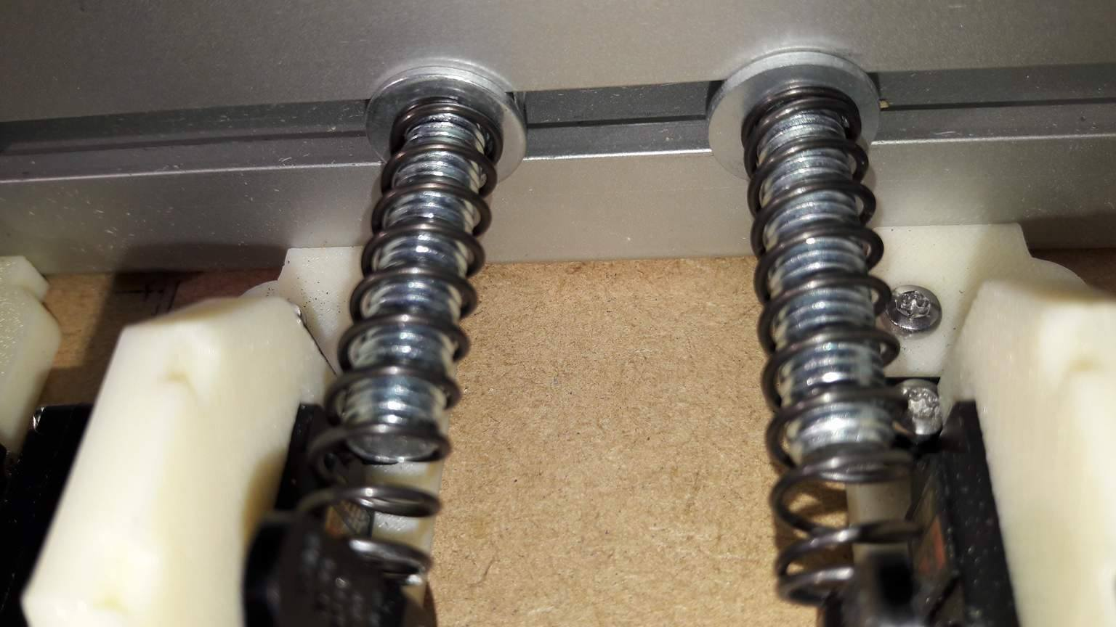

*Washers between springs and Minitec*

1. Servos:

* frequency and angle adjustable via PWM signal (serial also possible, see SBUS scheme)
* printed servo plate (6mm height) to level out servo horn compared to springs (radius of spring force determines torque, see Excel sheet), partly servo dependent (eventually bore extra holes for other servo model)
* printed servo holder for Hall switch sensor, servo dependent
* fed by bench power supply (5V, maximum 2A per servo)

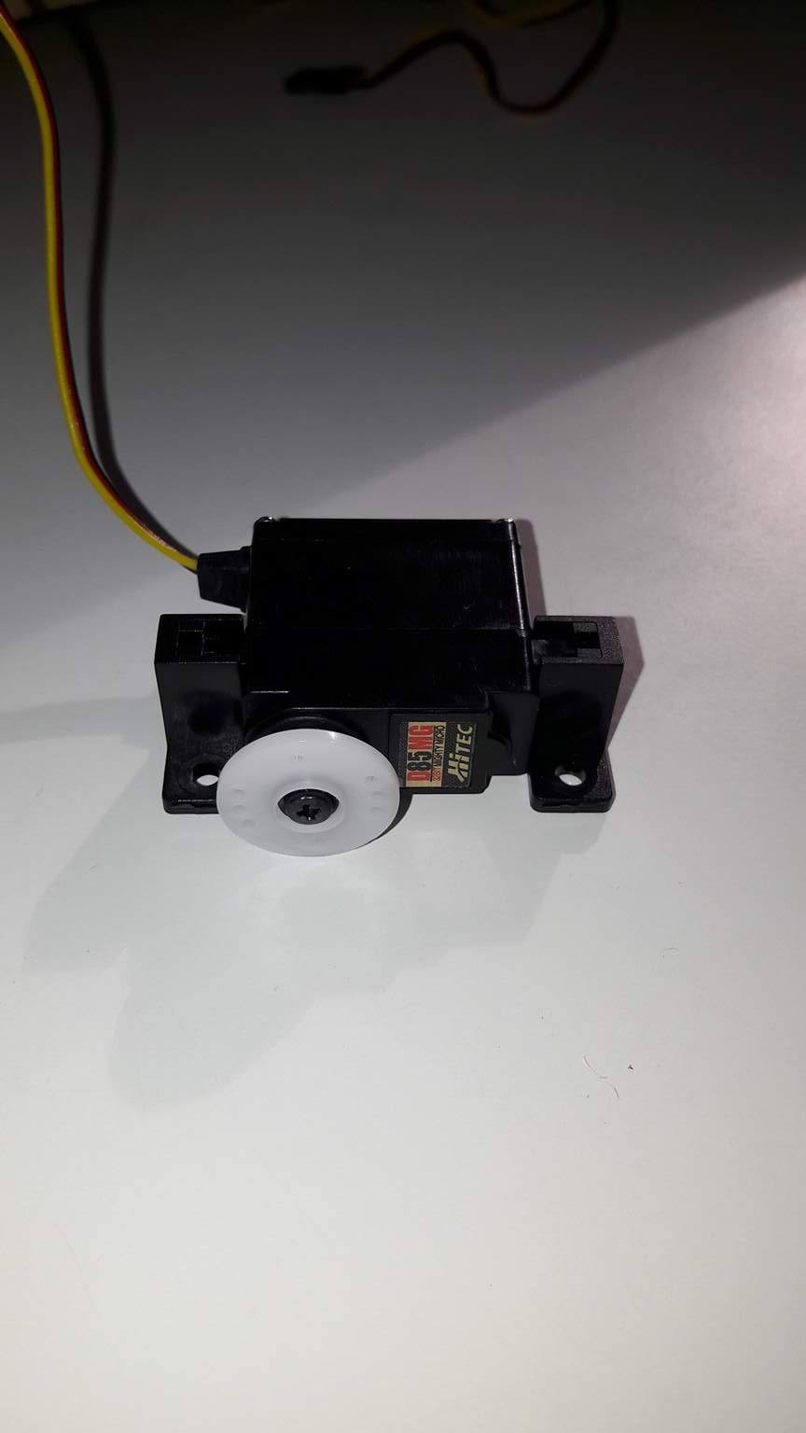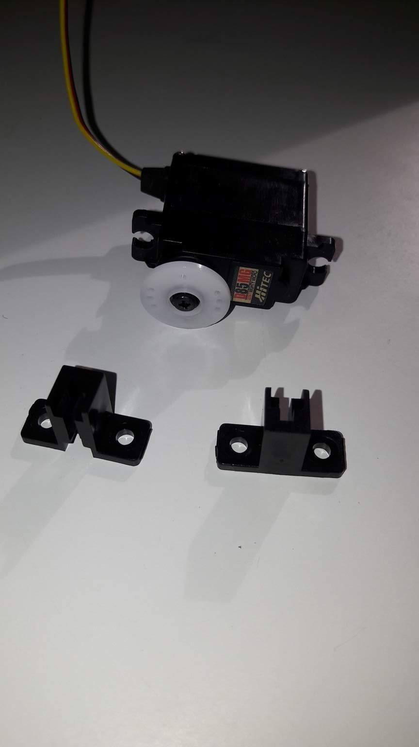

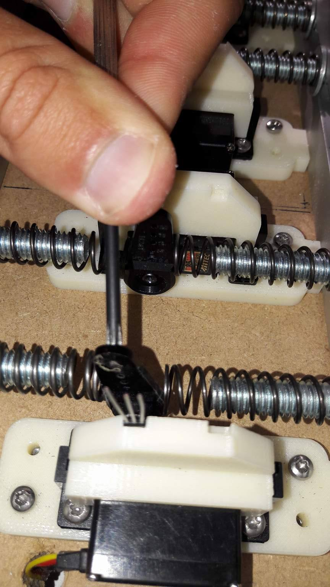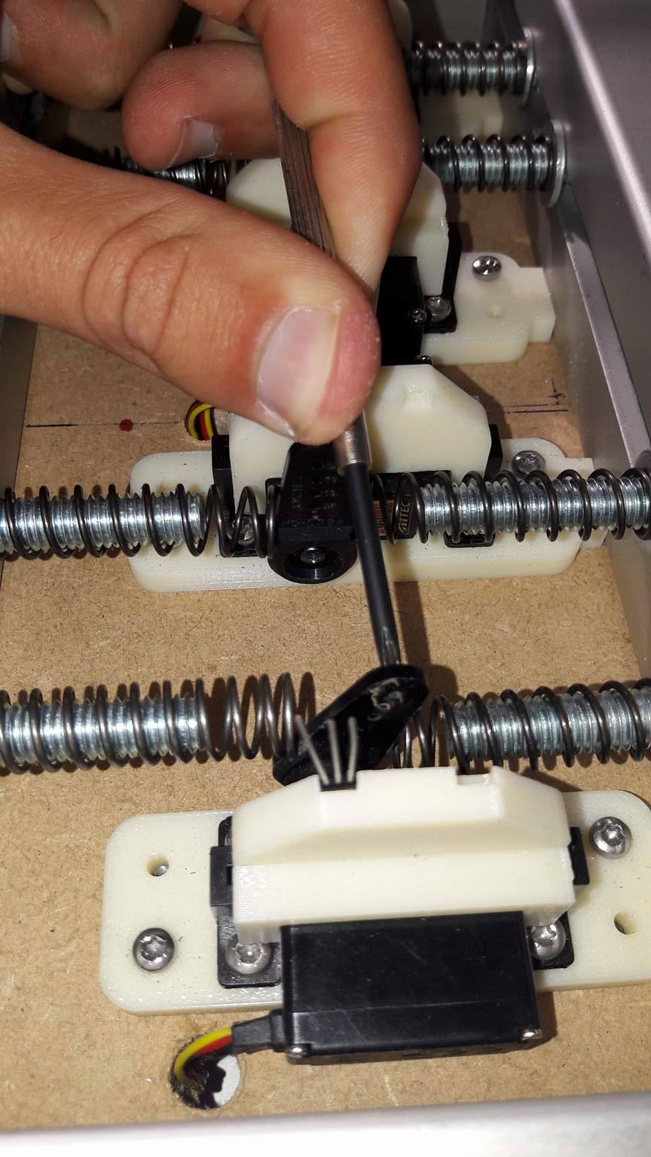

*Left and right servo horn pull-out (forced by user here, for photo)*

1. Plate:

* still decent leveling feet needed (now temporary), eventually additional bottom plate to attach electronics underneath setup
* has to fit in freezer and oven (eventually without Arduino)

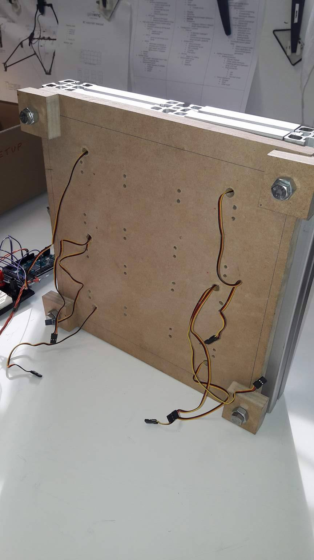

*Bottom of setup with (temporary) leveling feet*